Parle Tilak Vidyalaya Association’s
Mulund College of Commerce (Autonomous)
TECH-A-THON
Powered by
Academic Year: 2023-2024 Month: February
Date: 24th February 2024
Time: 24th February 9:30 A.M to 25th February 4:00 P.M
Venue: Lab 1 & Lab 3
Nature of Activity: Hackathon
Name of Department/Committee: TechnoBeat version.i.24
Level of Program/Activity: Inter-College Level
Mentors: 1. Dr.Hiren Dand.
2. Mr. Vishal Borude.
3. Mr. Siddhesh Gotekar.

Teacher In-Charge: Dr. Hiren Dand
Number of Teams: 16 Teams
Number of Participants: 64
Number of Male Participants: 59
Number of Female Participants: 05
Registration fee: Nil
Description of Participants: B.E. students, B.Sc. Computer Science students, B.Sc. Information Technology students.
A short description of the activity:
A technical Hackathon in a degree college typically involves students coming together to collaborate on solving real-world problems using technology. Participants form teams, brainstorm ideas, and then spend a set amount of time coding, designing, and testing their solutions. Mentors and judges are present to provide guidance and evaluate projects. The event usually culminates in presentations where teams showcase their creations, and prizes may be awarded to top performers. It's a dynamic environment that fosters creativity, teamwork, and innovation among students.
Learning Outcomes:
- Students enhance their programming, design, and problem-solving skills by working on real-world challenges within a limited timeframe.
- Collaborating with peers from diverse backgrounds fosters teamwork and communication skills as students learn to leverage each other's strengths and delegate tasks effectively.
- The pressure to develop a functional solution within a constrained timeframe encourages students to think creatively and innovate, often leading to novel approaches and solutions.
- Managing time efficiently to meet project deadlines is a crucial skill developed during hackathons, as participants must prioritize tasks and make quick decisions to stay on track.
- Presenting their projects to judges and peers helps students improve their presentation and communication skills, as they learn to articulate their ideas clearly and persuasively.
- Tackling complex problems during the hackathon cultivates students' critical thinking and problem-solving abilities, as they analyze issues, identify solutions, and iterate on their designs.
- Hackathons provide opportunities for students to network with industry professionals, mentors, and fellow participants, potentially leading to internships, job offers, or collaborations on future projects.

Inauguration Ceremony:
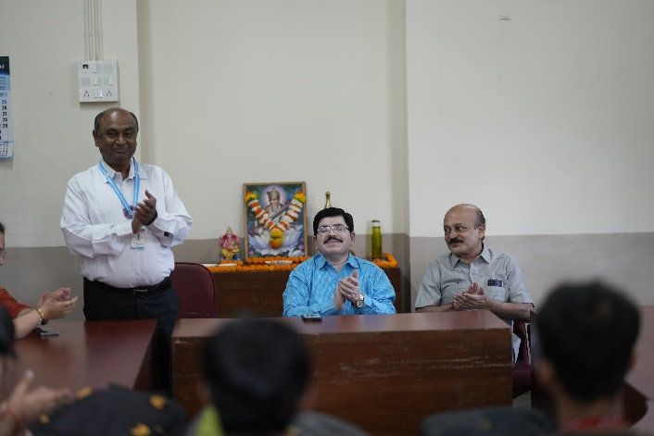
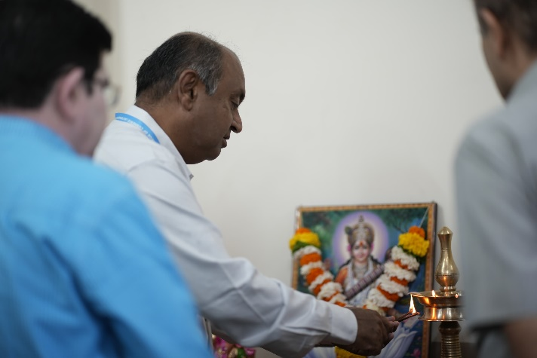
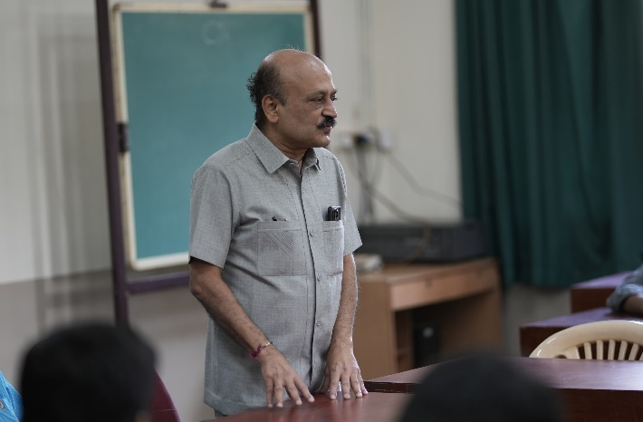
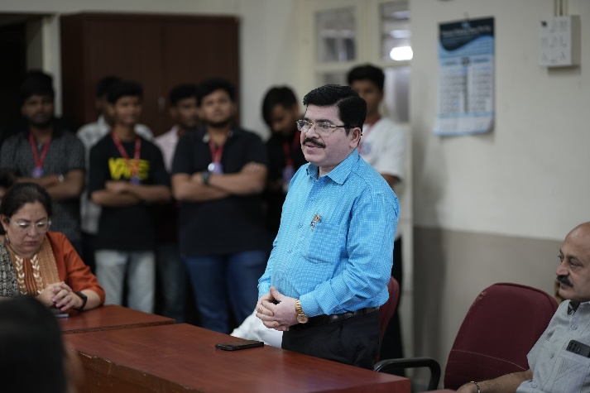
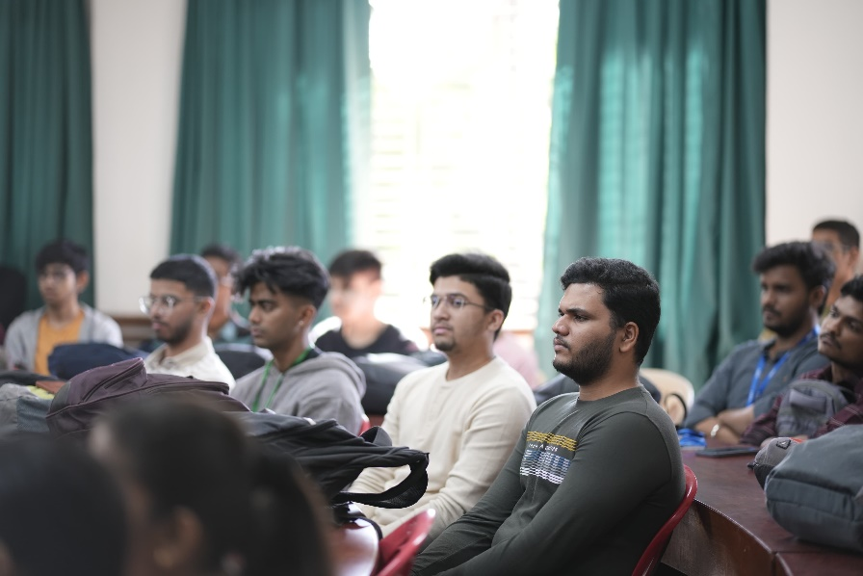
School of Computing and Technology organised a 24-hour Hackathon (Tech-a-thon) from 24 February 2024 10:20 a.m. to 25 February 2024 10:20 a.m. The inauguration of the event was held in the open access library from 9:40 a.m. The inauguration started with the welcome address by Dr. Hiren Dand. Dr. Shivaji Pawar expressed his views followed by CA Pramod Lele sir. The event was inaugurated by offering shrifal to Goddess Saraswati Maa and Ganesh Ji.
The participants were distributed in Lab 1 and Lab 3 where they were given the problem to be solved.

There were participant teams from:
- Veer Jijabai Technological Institute, Wadala (1 team - Girls)
- Sardar Patel Institute of Technology , Andheri (1 team)
- Fr. Conceicao Rodrigues College of Engineering, Bandra (1 team)
- Vidyavardhini's College of Engineering and Technology, Vasai (3 teams)
- Thadomal Shahani Engineering College, Bandra (1 team)
- Thakur College of Engineering and Technology, Kandivli (1 team)
- D J Shanghvi College of Engineering, Vile Parle (5 teams)
- Mulund College of Commerce (3 teams)

Total 16 teams participated including 1 team of girls.
There was an online pre-event talk and mentoring on February 23, 2024 by Dr. Hiren Dand and Mr. Aman Upadhyay, Senior Software Developer and Trainer, Eagerly.ai
The event started at 10:20 a.m. The teams started with their brainstorming discussions followed by the design and coding. The teams worked hard on solving the problem.
The lunch was served at 1:30 p.m. and the work continued thereafter. High tea and snacks were served at 5:00 p.m. There was elimination round at 7:30 p.m. and 7 teams were eliminated by 8:30 p.m. Dinner was served at 9:00 p.m. The students were busy solving the assigned problems. The tea was served twice during the night at 12:30 a.m. and 3:30 a.m. Breakfast was served at 8:00 a.m.
Beds were arranged in the auditorium for the participants to rest. Very few participants went to rest, while others were busy with the assignments.
The problem solving was stopped at 10:20 a.m. on February 2024. Three judges Dr. Tushar Sambare, Head, Department of Information Technology, Bunts Sangha’s S. M. Shetty College, Powai, Mr. Saubhagya Kumar, IT Business partner for Commercial Service and Operations, Thero Fischer and Mr. Mahendra Kane, Senior Manager, Business Development, Siemens Ltd. Were invited to judge the event.
The presentations started by diving the participants in three rooms. The presentations were over by 2:00 .pm. There was discussions on the projects demonstrated between the tree judges and final list of winners was announced.
Lunch was served from 1:30 p.m.
The winners were as follows:
Winners (First Prize: Rs. 12,000/- and a trophy)
- Aditya Ningule Sardar Patel Institute of Technology, Andheri
- Vaibhav Kore Sardar Patel Institute of Technology, Andheri
- Loukik Tayshete Sardar Patel Institute of Technology, Andheri
- Aditya Gangal Sardar Patel Institute of Technology, Andheri
First Runner Ups (Second Prize: Rs. 8000/- and a trophy)
- Karan Sankhe Vidyavardhini's College of Engineering and Technology, Vasai
- Kunal Choudary Vidyavardhini's College of Engineering and Technology, Vasai
- Sharvesh Singh Vidyavardhini's College of Engineering and Technology, Vasai
- Soham Patil Vidyavardhini's College of Engineering and Technology, Vasai
Second Runner Ups (Third Prize: Rs. 5000/- and a trophy)
- Mallank Gogri D J Shanghvi College of Engineering, Vile Parle
- Rahil Dabhi D J Shanghvi College of Engineering, Vile Parle
- Raj Shah D J Shanghvi College of Engineering, Vile Parle
- Meet Jain D J Shanghvi College of Engineering, Vile Parle
The judges were very happy with the entire events and thanked the management, principal and vice principal for inviting them for judging the event. While judging the event, they interacted with the participants and gained a lot of insight.
The valedictory function was arranged in the auditorium at 2:45 p.m. The judges gave the suggestions and views. This was followed by the announcement of results and the distribution of awards and certificates. Every participant was given the participation certificate.
The entire event concluded at 4:00 p.m.
Link for the photographs: https://mccmulund.ac.in/newweb/gallery.php?f=TECH-A-THON%202024
Team Technobeat

Glimpse of The Event:
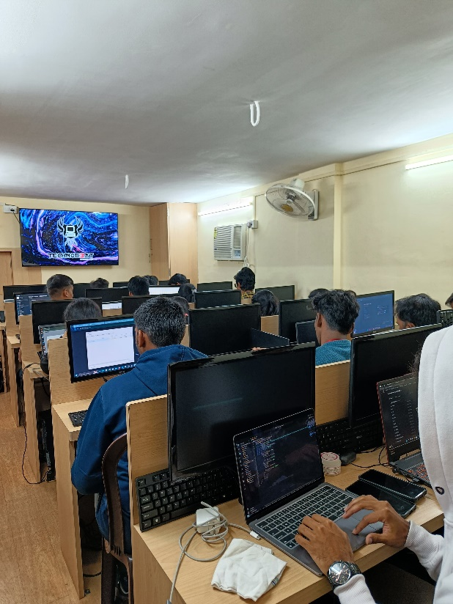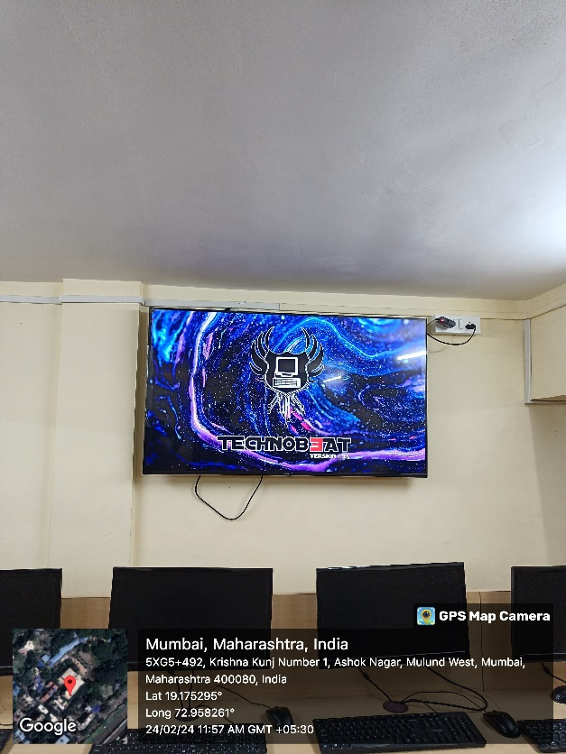
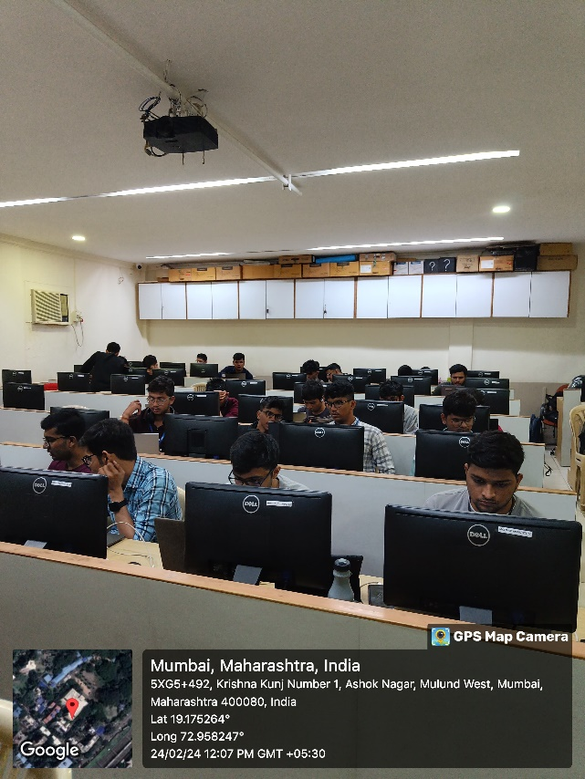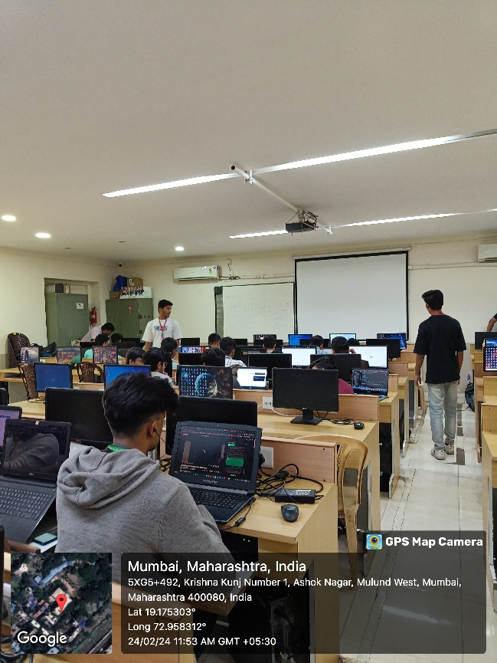
Prize Distribution:
1st Prize: Debug Thugs
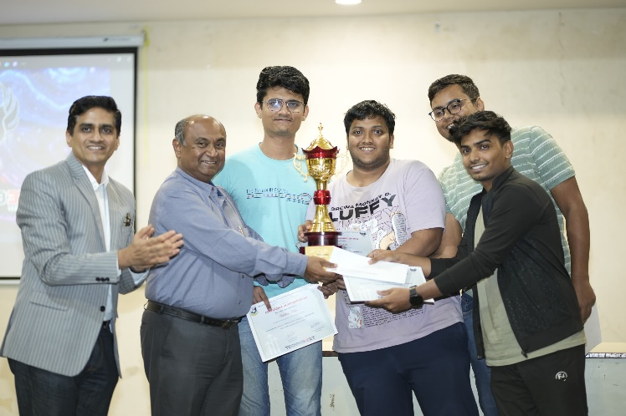
2nd Prize: Byte Coders
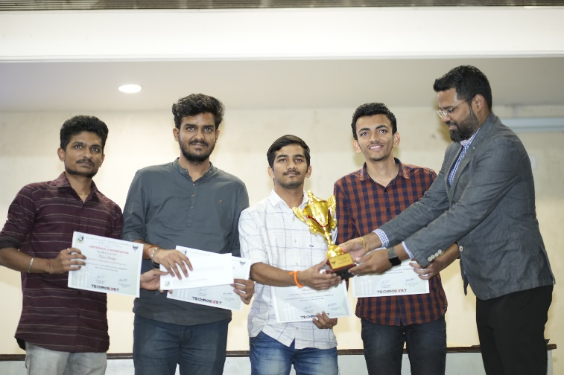
3rd Prize: Byte-me
